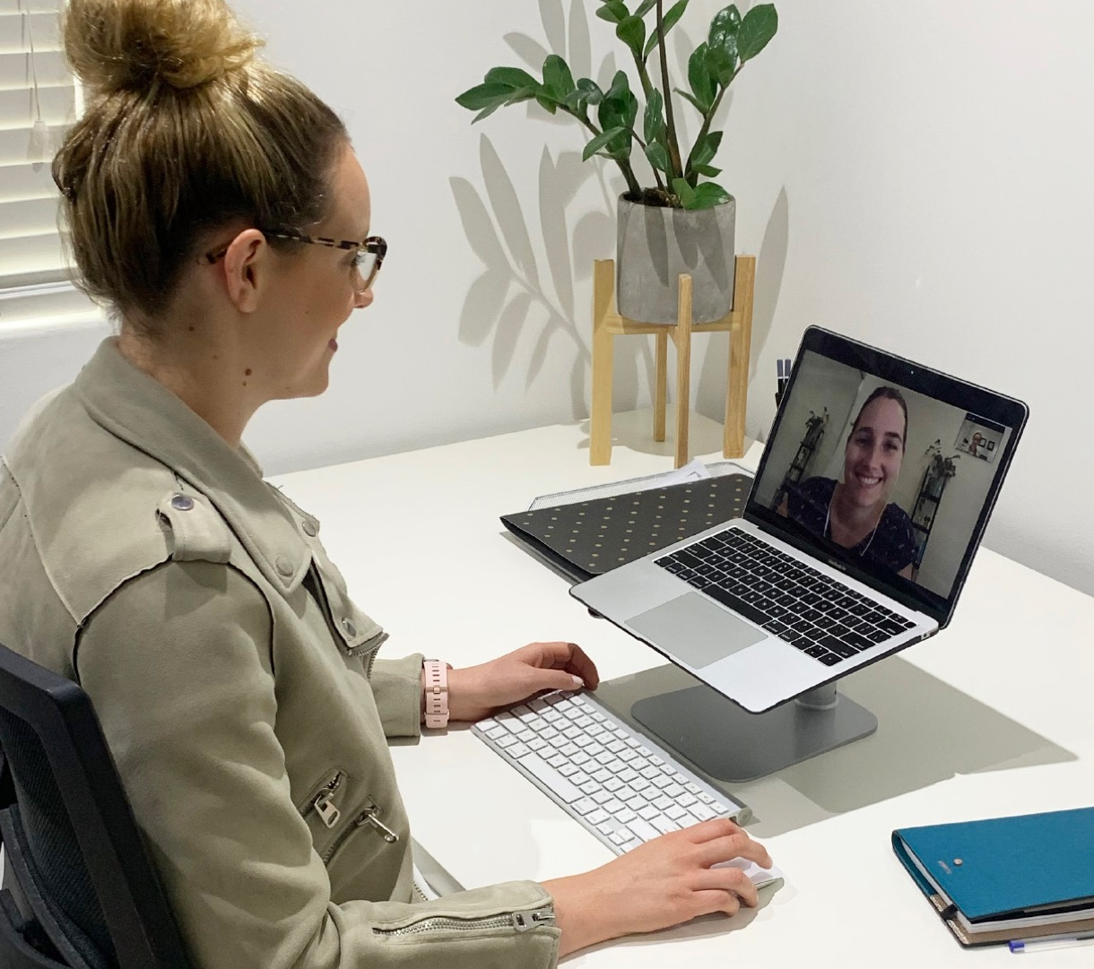

***Dear Dr Name,***

***As you are no doubt aware, new temporary telehealth items have been added to the MBS to help reduce risk of community transmission of COVID-19. The latest round of additions included items specific to Allied Health Professionals, including dietitians. Continuity of care and ease of access to all healthcare services has never been more important or challenging, so I have included some information below to answer any questions you may have about how we can continue to work together.***

Disorder Treatment Plan (item 90250-90253 by GP, 90254-90257 by other medical professional and 90260-90263 by psychiatrist or paediatrician) may also be eligible. Residents of a residential aged care facility may be eligible if they have a multidisciplinary care plan (item 731).

*Patients who already have a valid referral to a dietitian under these items do not need to get a new one to access telehealth services.*

Patients who do not meet the above criteria are still eligible to access a dietitian via telehealth, however no Medicare rebate is applicable. Many private health funds will rebate on telehealth consultations at this time and patients should be encouraged to contact their fund directly for further information.

***I appreciate your continued support during this uncertain time. Please do not hesitate to contact me if you would like to discuss further.***

***Best regards,***

***Name here***

**Are dietitians still allowed to practice?**

Yes. Like GPs, allied health businesses are permitted to keep operating, as long as physical distancing guidelines are observed. With the latest changes to the MBS, I am now offering telehealth appointments to new and existing clients.

**Is telehealth secure and private?**

The same privacy requirements that apply to face-to-face consultations apply to telehealth consultations. Practitioners have a responsibility to ensure that their chosen technology solution satisfies privacy laws.

**Who is eligible for a Medicate rebate on a dietetic telehealth consultation?**

Eligibility criteria for community-based patients is the same as for face-to-face patients. Patients may be eligible if they have a chronic condition and have a valid GP Management Plan (item 721) and Team Care Arrangement (item 723). Eating disorder patients with a valid Eating

Add your company logo and contact details here