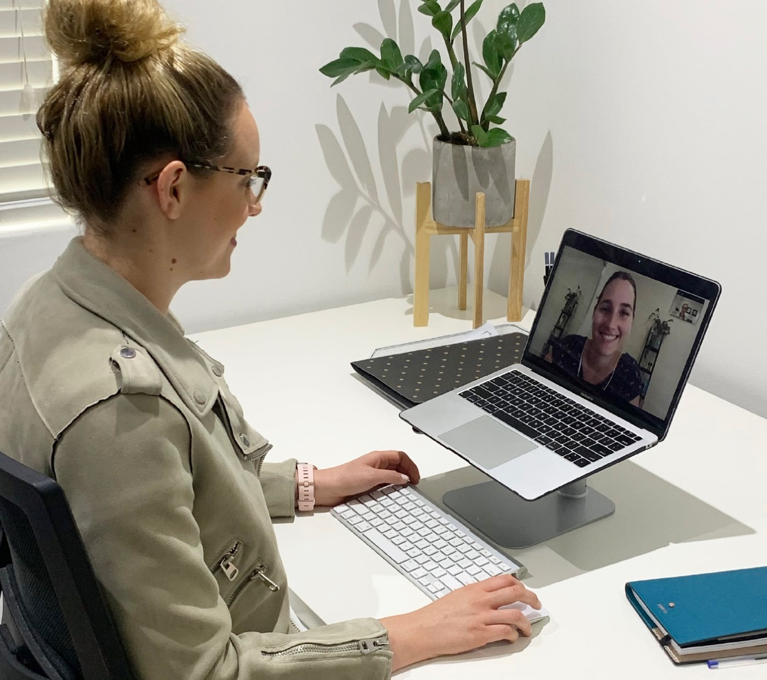

**Is it secure and private?**The same privacy requirements that apply to face-to-face consultations apply to telehealth consultations. Practitioners have a responsibility to ensure that their chosen technology solution, whether it is videoconferencing or phone, satisfies   
privacy laws.

**Will I still get the same level of care?**Yes. Telehealth is not appropriate for all healthcare problems, however this initiative will allow many people to continue to receive ongoing care during this time while maintaining physical distancing. If it is more appropriate to see you in person, your dietitian will arrange this - allied health businesses (including dietitians) are permitted to remain operating as an essential service. This is also the case if you don’t have the technology required to participate in a telehealth consultation or if you would simply prefer a face-to-face consultation.

**Is it covered by Medicare?**The recent changes mean that more services and more people are eligible for a Medicare rebate for telehealth services. Please check with your dietitian to determine if you are eligible.

*If you already have a valid referral to a dietitian from your GP, you do not need to get a new one to access telehealth services.*

If you do not have a chronic condition or complex needs (i.e. you are not eligible for a Medicare rebate), you may still access a dietitian via telehealth, however there will be a fee.

**Can I claim the cost on private health insurance?**Many private health funds provide rebates for dietetic services. The rebate amount and claim limits will vary from fund to fund, so contact your fund to check your entitlements.

***­In recent weeks, the Australian Government has announced changes designed to make sure you can still access the healthcare you need during the COVID-19 crisis, even if you are self-isolating.***

**What is telehealth?**Telehealth refers to the use of technology to deliver health services outside of the usual   
face-to-face setting. This could be via phone   
call or videoconference.

Add your company logo and contact details here